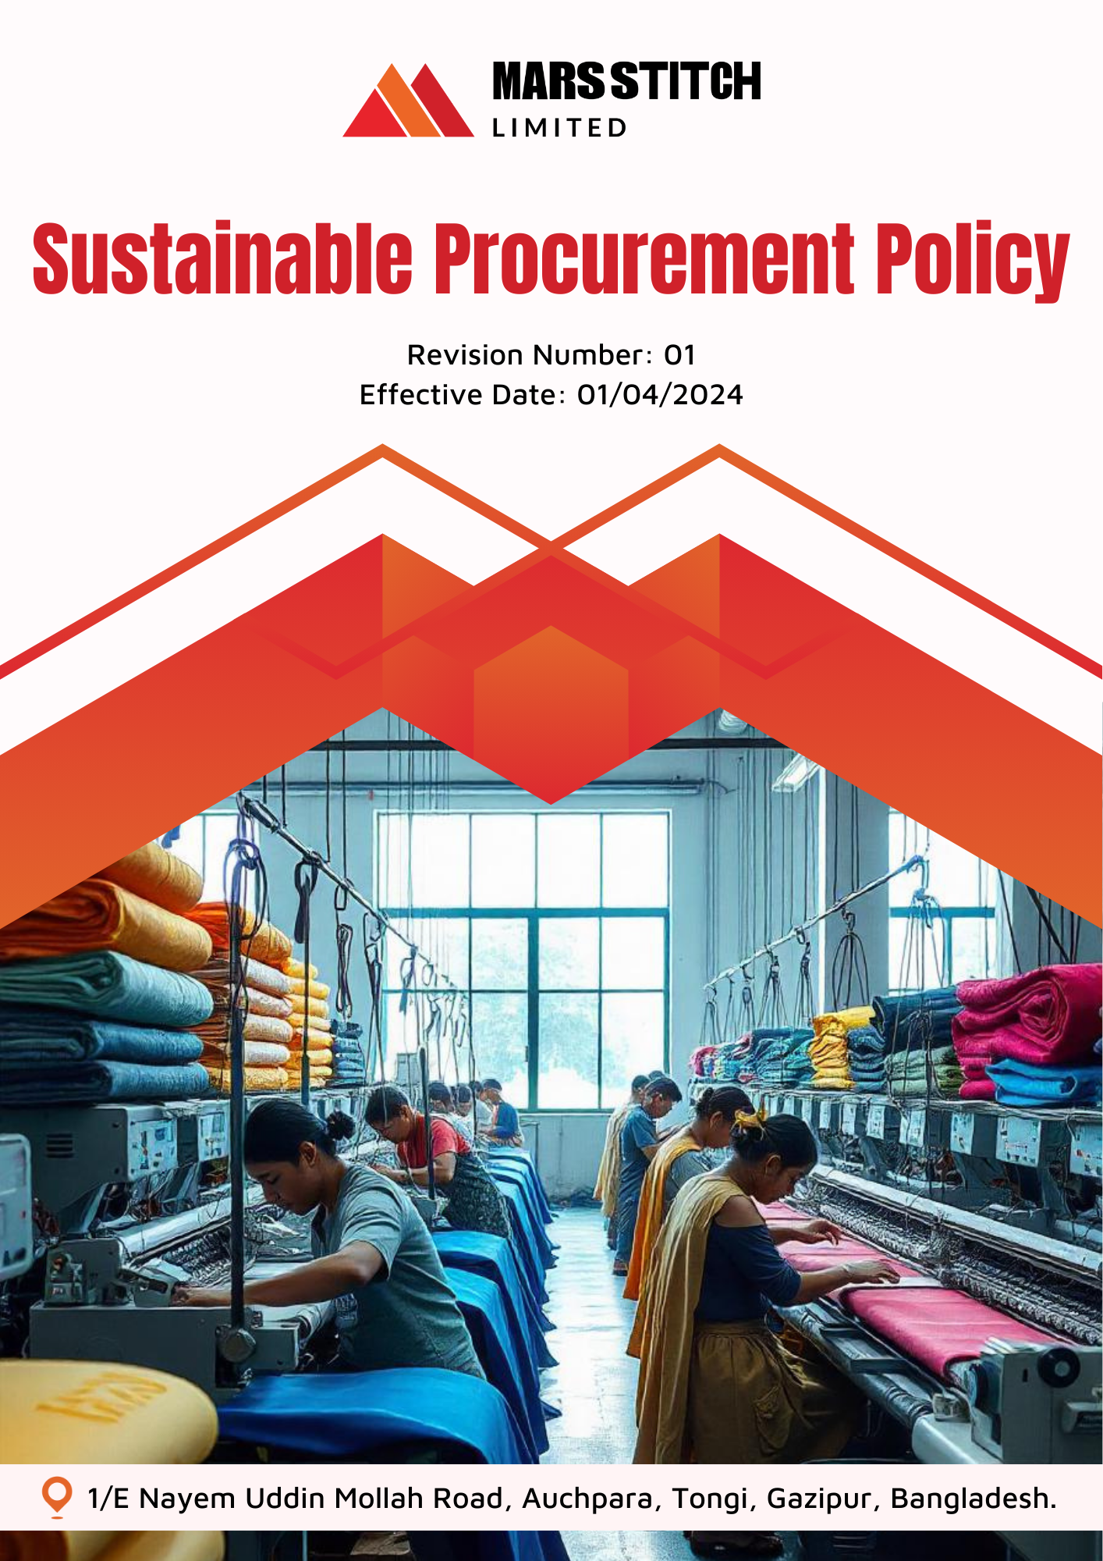

Policy Number

04313

Prepared by

Maria G. White

mariawhite@workerwrite.com
INDEX
⧫ INTRODUCTION 3
⧫ SCOPE 3
⧫ POLICY STATEMENT 3
⧫ KEY FOCUS AREA 4
⧫ QUALITATIVE TARGETS 4
⧫ QUANTITATIVE TARGET 5
⧫ THE ORGANIZATION OR PERSON RESPONSIBLE FOR IMPLEMENTING THE POLICY 6
⧫ CONTINUES IMPROVEMENT 7
⧫ REPORTING 7
⧫ DISCIPLINARY MEASURES FOR POLICY VIOLATIONS 8
⧫ REVIEW MECHANISM 8
⧫ EMPLOYEE ACKNOWLEDGEMENT FORM 9

- INTRODUCTION
Mars Stitch Ltd. is committed to fostering sustainable practices throughout its procurement processes. As a leader in the textile and garment industry, we recognize the importance of sourcing materials and services responsibly to minimize our environmental footprint and promote ethical standards. Our Sustainable Procurement Policy outlines our commitment to integrating environmental, social, and economic considerations into all procurement decisions.

At Mars Stitch Ltd., we believe that sustainability is integral to our success. This policy serves as a framework for ensuring that our supply chain aligns with our values of environmental stewardship, human rights, and business ethics. By working collaboratively with our suppliers and stakeholders, we aim to drive positive change and create long-term value for our communities and customers.
- SCOPE
This policy applies to all procurement activities conducted by Mars Stitch Ltd., including the sourcing of raw materials, goods, and services. It covers all employees, worker, suppliers, contractors, contractual worker and business partners involved in our supply chain.

Sr. No. | Name of Site | Address
1 | Mars Stitch Ltd. | 1/E Nayem Uddin Mollah Road, Auchpara, Tongi, Gazipur, Bangladesh.
- POLICY STATEMENT
Mars Stitch Ltd. is dedicated to embedding sustainability into every aspect of our procurement processes. By prioritizing environmentally friendly practices, ethical labor standards, and economic fairness, we aim to build a resilient and responsible supply chain. Through rigorous supplier evaluations and continuous collaboration, we are committed to setting a benchmark for sustainable procurement excellence.
- KEY FOCUS AREA
Mars Stitch Ltd. focuses on the following principles to achieve sustainable procurement:
- Environmental Responsibility: Ensure that all materials and services sourced align with environmental sustainability goals, including reducing carbon emissions and promoting resource efficiency.
- Ethical Labor Practices: Partner with suppliers that uphold labor rights, prohibit child and forced labor, and promote safe working conditions
- Fair Trade: Prioritize suppliers that adhere to fair trade practices and contribute to equitable economic growth in their communities.
- Supplier Diversity: Engage with a diverse range of suppliers, including small and minority-owned businesses, to promote inclusive economic opportunities.
- Compliance and Transparency: Ensure all suppliers comply with legal and regulatory requirements, and promote transparency throughout the supply chain.
- QUALITATIVE TARGETS
Environmental Responsibility:
- Source materials and services that align with environmental sustainability goals, prioritizing renewable and recycled resources.
- Engage with suppliers to adopt eco-friendly manufacturing practices and reduce carbon emissions.
- Promote the use of sustainable packaging to minimize waste and environmental impact.
Ethical Labor Practices:
- Conduct regular assessments to ensure suppliers uphold labor rights and prohibit child and forced labor.
- Provide training programs to suppliers on implementing ethical labor standards.
- Build long-term partnerships with suppliers committed to improving workplace safety and human rights.

Fair Trade:
- Partner with suppliers certified under fair trade standards to promote equitable economic growth.
- Support local businesses to strengthen regional economies and reduce transportation emissions.
- Collaborate with suppliers to establish equitable payment practices and improve working conditions.
Supplier Diversity:
- Develop programs to support small and minority-owned businesses in participating in the procurement process.
- Create opportunities for diverse suppliers to contribute to supply chain innovation.
- Foster mentoring relationships to help small businesses build capacity and sustainability.
Compliance and Transparency:
- Enforce strict adherence to Mars Stitch Ltd.'s Supplier Code of Conduct across all suppliers.
- QUANTITATIVE TARGET
Mars Stitch Ltd. has set measurable targets to reinforce sustainable procurement, with 2023 as the baseline year.
Environmental Responsibility:
- Source 15% of raw materials from renewable resources by 2026.
- Reduce packaging waste by 20% by 2026, ensuring 100% of packaging materials are reusable or biodegradable by 2026.
- Partner with 5 suppliers annually to implement environmentally sustainable practices.
Ethical Labor Practices:
- Audit 100% of Tier 1 and Tier 2 suppliers annually for labor compliance by 2026.
- Train 100% of suppliers on ethical labor practices, ensuring participation in annual workshops by 2026.
- Develop long-term contracts with 20% of high-performing ethical suppliers by 2026.
Fair Trade:
- Increase procurement from fair trade-certified suppliers to 50% by 2026.
- Reduce supply chain-related emissions by 15% by 2026 through enhanced logistics and local sourcing initiatives.
- Collaborate with 5 suppliers annually to promote equitable payment practices.
Supplier Diversity:
- Achieve 15% growth in contracts with small and minority-owned businesses by 2026.
- Conduct biannual diversity reviews for suppliers to evaluate inclusion metrics.
- Partner with 5 new diverse suppliers annually, providing mentorship to help improve their capacity.
Compliance and Transparency:
- Ensure 100% of suppliers sign the Supplier Code of Conduct by 2026.
- THE ORGANIZATION OR PERSON RESPONSIBLE FOR IMPLEMENTING THE POLICY
Mars Stitch Ltd. has designated a dedicated committee to ensure the successful implementation of this policy. This committee is responsible for monitoring, reviewing, and enforcing the policy while maintaining compliance with internal and external standards.
Sr. No. | Name | Designation | Committee Designation
1. | S.M Azmal Huda | General Manager(Operation) | President
2. | Mahmodul Hasan | Manager – HR, Admin & Com. | Vice President
3. | Eva Akter | Executive-Welfare | Member Secretary
4. | Nonda Gopal | Sr. Executive -Compliance | Member
5. | Md.Shanta | Maintenance In-charge | Member
6. | Md. Masud | Asst. Manager-Admin | Member
7. | Mr. Antar | Asst. Manager-Store | Member
8. | Md. Samim | Cutting Asst. | Member
9. | Md. Nayeem Hosan | Quality Inspector | Member
10. | Mst. Ruma Akter | Operator(Sewing) | Member
11. | Mst. Jushna Begam | Operator(Sewing) | Member
12. | Mst. Mira | Finishing Asst. | Member
- CONTINUES IMPROVEMENT
Mars Stitch Ltd. is committed to continuous improvement in sustainable procurement through:
- Regular updates to the Sustainable Procurement Policy to reflect evolving industry standards and best practices.
- Establishing collaborative forums with suppliers to share innovations and address sustainability challenges.
- Monitoring and evaluating procurement performance through key performance indicators (KPIs).
- Encouraging feedback from suppliers, employees, and stakeholders to identify improvement opportunities.
- REPORTING
To ensure transparency and accountability:
- Annual Procurement Report: Publish a detailed report on sustainable procurement performance, including metrics and case studies.
- Stakeholder Engagement: Conduct annual supplier summits to discuss sustainability goals and progress.
- Incident Reporting: Maintain a transparent mechanism for reporting and addressing procurement-related violations.
- DISCIPLINARY MEASURES FOR POLICY VIOLATIONS
Mars Stitch Ltd. enforces strict measures for violations of the Sustainable Procurement Policy. Suppliers found in breach of the policy may face:
- Contract termination for severe or repeated violations.
- Temporary suspension pending investigation of compliance issues.
- Reporting of violations to relevant authorities for legal action.

Mars Stitch Ltd. ensures that all actions are conducted fairly and transparently, prioritizing remediation wherever possible.
- REVIEW MECHANISM
This policy will be reviewed annually by the Sr. Executive -Compliance, ensuring alignment with Mars Stitch Ltd.'s sustainability goals and global standards. The Sustainability Office will assess the policy's effectiveness, incorporating stakeholder feedback and addressing emerging challenges to maintain relevance and impact.

Prepared By : Sr. Executive -Compliance Approved By : General Manager
Next Review Date : 01/04/2025
- EMPLOYEE ACKNOWLEDGEMENT FORM
By signing this form, employees acknowledge their understanding of and commitment to Mars Stitch Ltd.'s Sustainable Procurement Policy. Compliance with this policy is a shared responsibility and an integral part of fostering a sustainable and ethical supply chain. Employees agree to uphold the principles outlined in this policy and actively participate in implementing sustainable practices throughout their operations.

This includes adhering to the company's standards for environmental responsibility, ethical labor practices, and fair trade, as well as promptly addressing and reporting any deviations. By committing to these guidelines, employees play a vital role in supporting Mars Stitch Ltd.'s vision of sustainability and contributing to a positive and responsible global impact.

Employee Name:

Designation:

Signature:

Date:

